- Five concurrent coplanar forces act on a body as shown in figure. Find the forces P and Q such that the resultant of five forces is zero. Dec - 2009 M - 05 ,May - 2013 M - 04
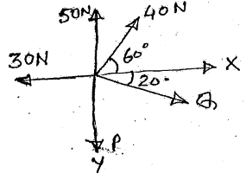
Ans: P=81 N, Q=10.65N
- For the system shown in figure determine (i) The required value of α if resultant of three forces is to be vertical (ii) The corresponding magnitude of resultant. Dec - 2008 M - 05
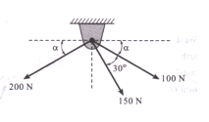Ans: α=21.73, R=229-29N
- Find resultant of the force system. Dec - 2012 Q 1.(a) M - 04
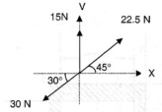
- A force R = 25 N has components F_{a} ,F_{b} and F_{c} as shown in figure. If F_{c}= 20 N. Find F_{a} and F_{b.} Dec - 2007 Q 1.(b) M - 05
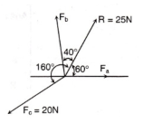
Ans: F_{a}= 33.9 Nm, F_{b}= 35.03 Nm

- The striker of caram board lying on the board is being pulled by four players as shown in figure. The players are sitting exactly at the center of the four sides. Determine the resultant of forces in magnitude and direction. May - 2008 Q 2.(a) M - 10
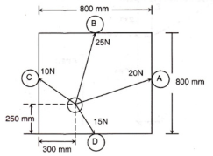Ans: θ=45.89,R=29.09N
- Resolve 15 kN force acting at A into two parallel components at ‘B’ and ‘C’. Dec - 2011 M - 05
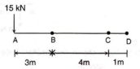
- The resultant of the three forces shown in figure and other two forces P and Q acting at ‘A’ and ‘B’ is a couple of magnitude 120 kN clockwise. Determine the force P and Q. May - 2012 M - 05
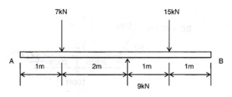Ans: P=29000N, Q=16000N
- Resolve system of forces shown in figure into a force and couple at point ‘A’ Dec - 2007 M - 05
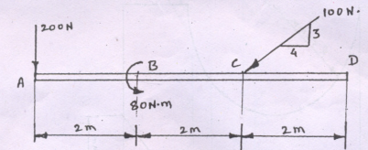
Ans: R=272.03N, M_{o}= 160 Nm, Ө =72.89
- Determine resultant of the parallel force shown in figure w.r.t. ‘O’, radius is 1 m.
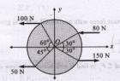R=272.03N, Ma=160Nm, θ=72.89
- A system of forces acting on a bell crank is as shown. Determine the magnitude, direction and the point of application of the resultant w.r.t.’O’ May - 2014 M – 06, Dec - 2008 M – 10
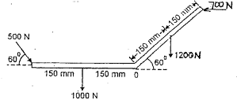Ans:R=2671.89N, θ=80.03
- Find out resultant of given( liver ) force system w.r.t. ‘B’ May - 2013 M - 06
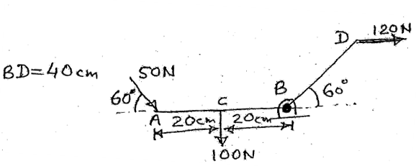Ans: R=203.86N, θ=44.66
- Replace the system of forces and couples by a single force and locate the point on the x axis through which the line of action of the resultant passes. Dec - 2012 M - 06
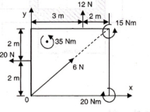Ans: R=21.96N, θ=45.8
- Find resultant force and moment at point A. May - 2010 M - 05
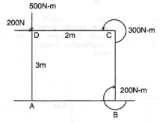Ans: R=538.5N, θ=68.19, Ma=500Nm
- Determine the resultant of the system of forces shown in figure. Locate the point where the resultant cuts the base AB. Dec - 2009 M - 10
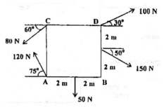Ans: R=131.14N , θ=31.38
- Find the resultant of the force system acting on a body OABC shown in figure. Also find the points where the resultant will cu the x and y axis. What is the distance of resultant from ‘O’ Dec - 2010 M - 05
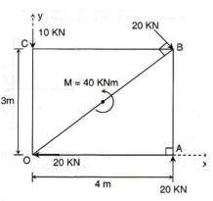Ans: R=10KN, θ=36.87
- Replace the loading on the frame by a force and moment at point A. May - 2009 M - 05
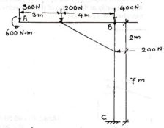Ans : R=510.78N, θ=66.95, d=0
- Find distance Y so that C.G. of given area in figure has co-ordinates ( 25,20) Dec - 2007 Q M - 05
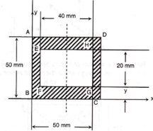Ans: y=25.62mm
- Find the centroid of the shaded area shown in figure. May - 2010 M - 10
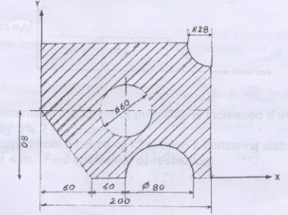
- Find centroid of the shaded area. May - 2013 M - 08

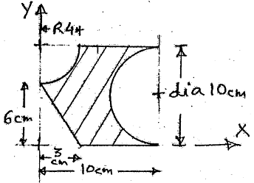Ans: x= 4.093cm, y=4.63cm
- Find the centroid of shaded area. Dec - 2012 M - 08
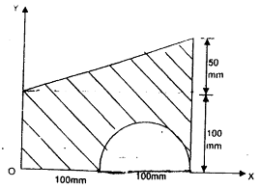Ans: x=98.59mm, y=71.18mm

